Test Case: tc006_SPX_Dev5_Crear_Requisicion_Spot_Tipo_Cobro_Proyect_Urgent
Step 1 - Enter username and password and click to button Enter: Credentials Entered
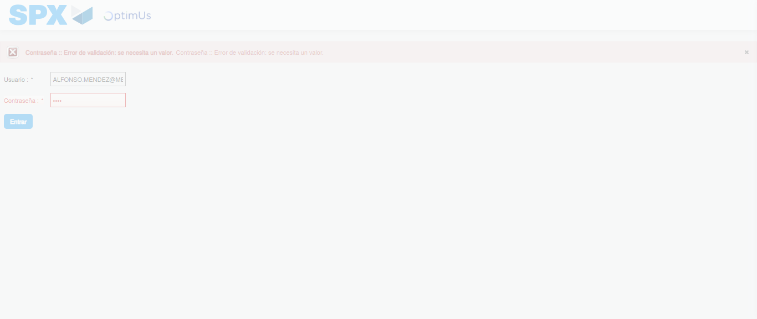Image file-name: QC_Testing-tc006_SPX_Dev5_Crear_Requisicion_Spot_Tipo_Cobro_Proyect_Urgent-1783376778473

Step 2 - Select to UEN and Access to Spot Buy Requisitions : UEN Correctly selected and Correct access
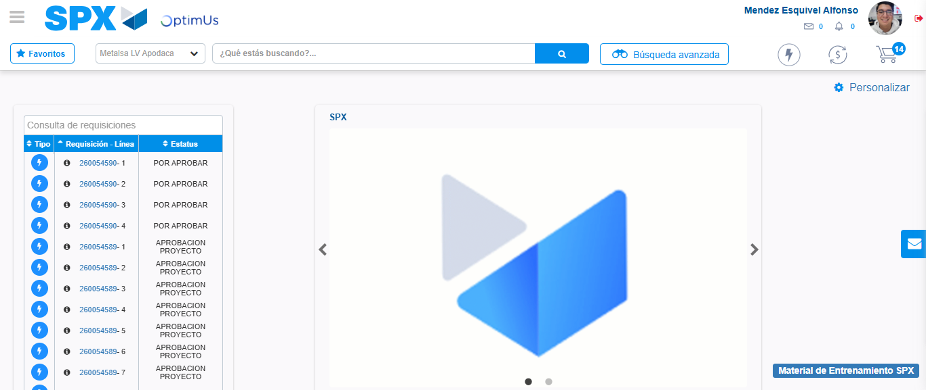Image file-name: QC_Testing-tc006_SPX_Dev5_Crear_Requisicion_Spot_Tipo_Cobro_Proyect_Urgent-1783376804043

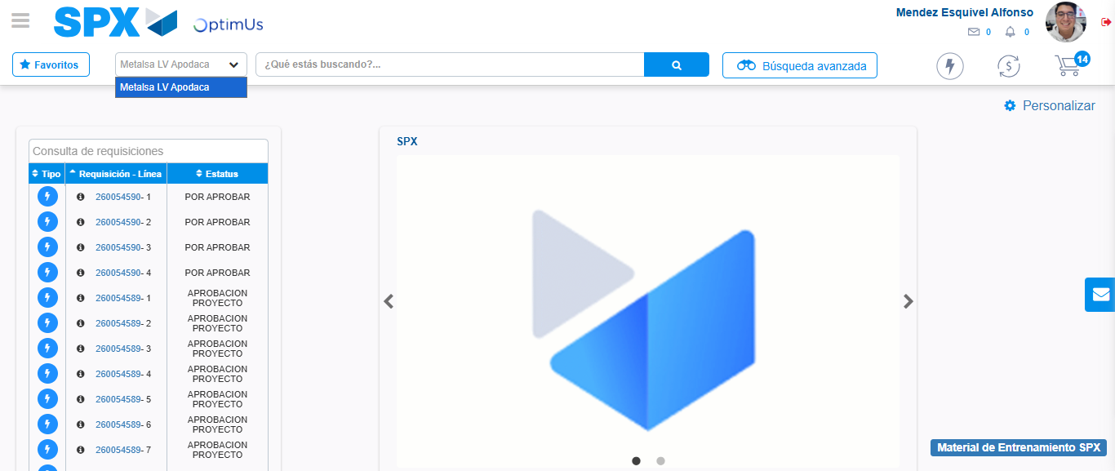Image file-name: QC_Testing-tc006_SPX_Dev5_Crear_Requisicion_Spot_Tipo_Cobro_Proyect_Urgent-1783376806501

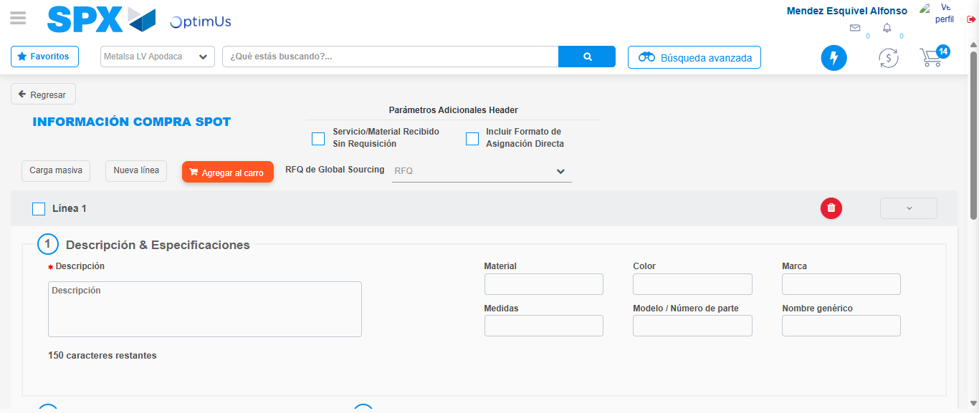Image file-name: QC_Testing-tc006_SPX_Dev5_Crear_Requisicion_Spot_Tipo_Cobro_Proyect_Urgent-1783376827620

Step 3 - Data Capture Spot Buy Requisition: Data captured correctly
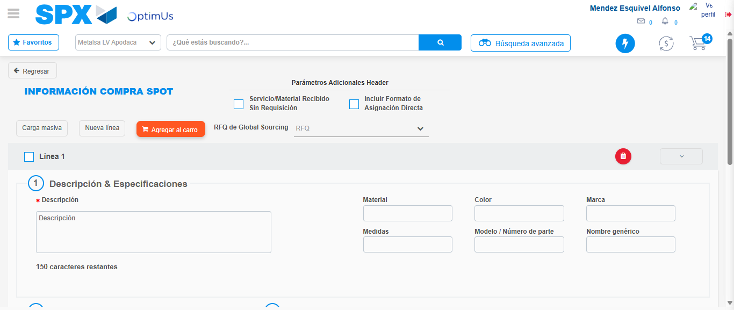Image file-name: QC_Testing-tc006_SPX_Dev5_Crear_Requisicion_Spot_Tipo_Cobro_Proyect_Urgent-1783376827940

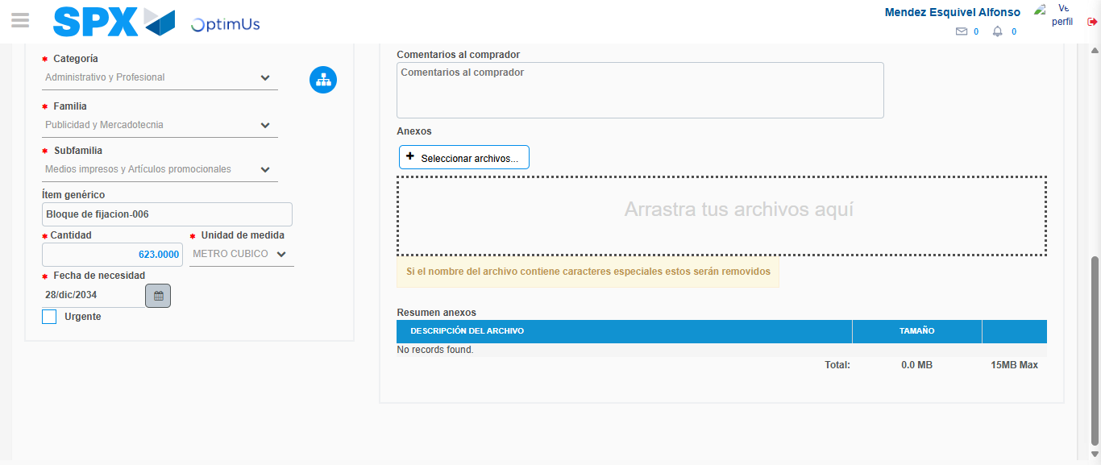Image file-name: QC_Testing-tc006_SPX_Dev5_Crear_Requisicion_Spot_Tipo_Cobro_Proyect_Urgent-1783376837733

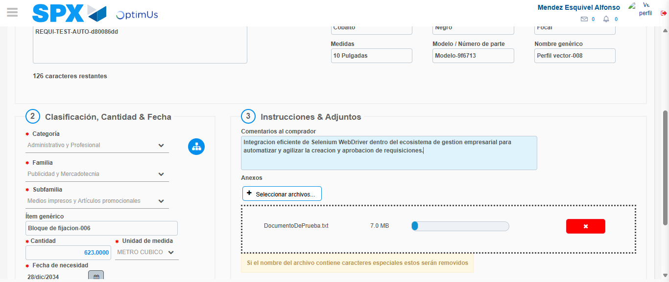Image file-name: QC_Testing-tc006_SPX_Dev5_Crear_Requisicion_Spot_Tipo_Cobro_Proyect_Urgent-1783376838487

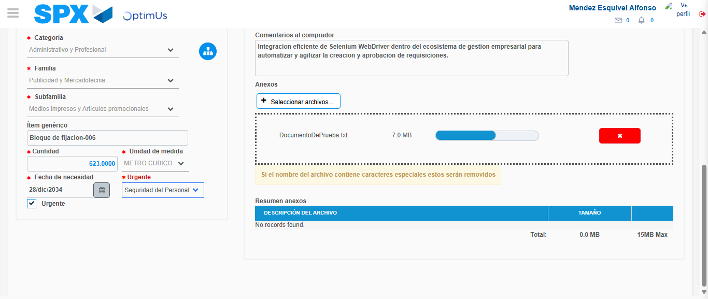Image file-name: QC_Testing-tc006_SPX_Dev5_Crear_Requisicion_Spot_Tipo_Cobro_Proyect_Urgent-1783376842105

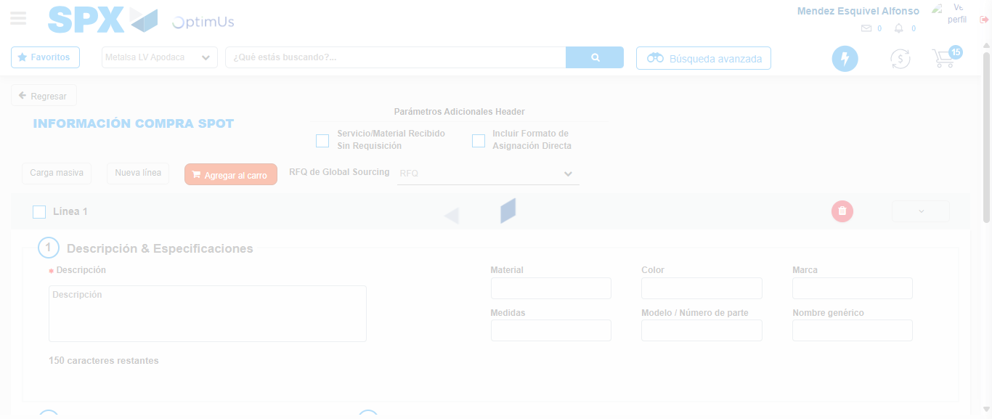Image file-name: QC_Testing-tc006_SPX_Dev5_Crear_Requisicion_Spot_Tipo_Cobro_Proyect_Urgent-1783376846935

Step 7 - Return to Main Page SPX : Return to Main Page SPX
Image file-name: QC_Testing-tc006_SPX_Dev5_Crear_Requisicion_Spot_Tipo_Cobro_Proyect_Urgent-1783376804043

Image file-name: QC_Testing-tc006_SPX_Dev5_Crear_Requisicion_Spot_Tipo_Cobro_Proyect_Urgent-1783376806501

Image file-name: QC_Testing-tc006_SPX_Dev5_Crear_Requisicion_Spot_Tipo_Cobro_Proyect_Urgent-1783376827620

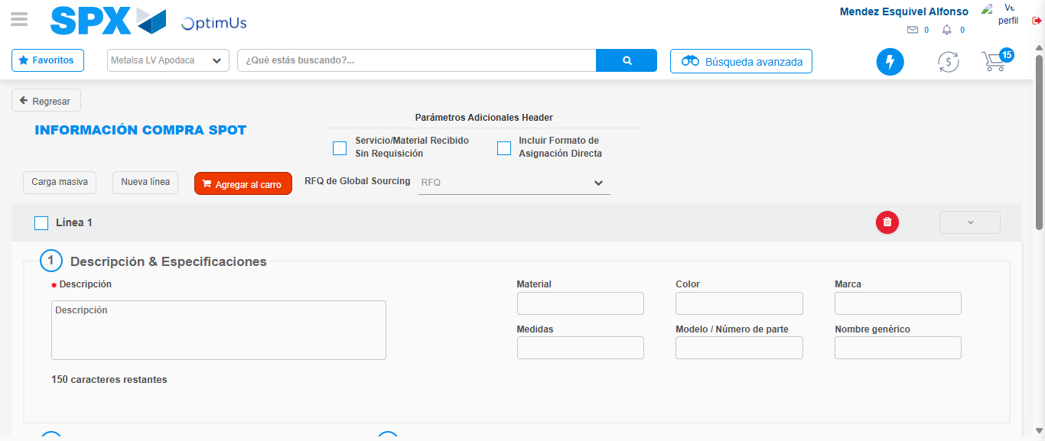Image file-name: QC_Testing-tc006_SPX_Dev5_Crear_Requisicion_Spot_Tipo_Cobro_Proyect_Urgent-1783376849164

Image file-name: QC_Testing-tc006_SPX_Dev5_Crear_Requisicion_Spot_Tipo_Cobro_Proyect_Urgent-1783376849333

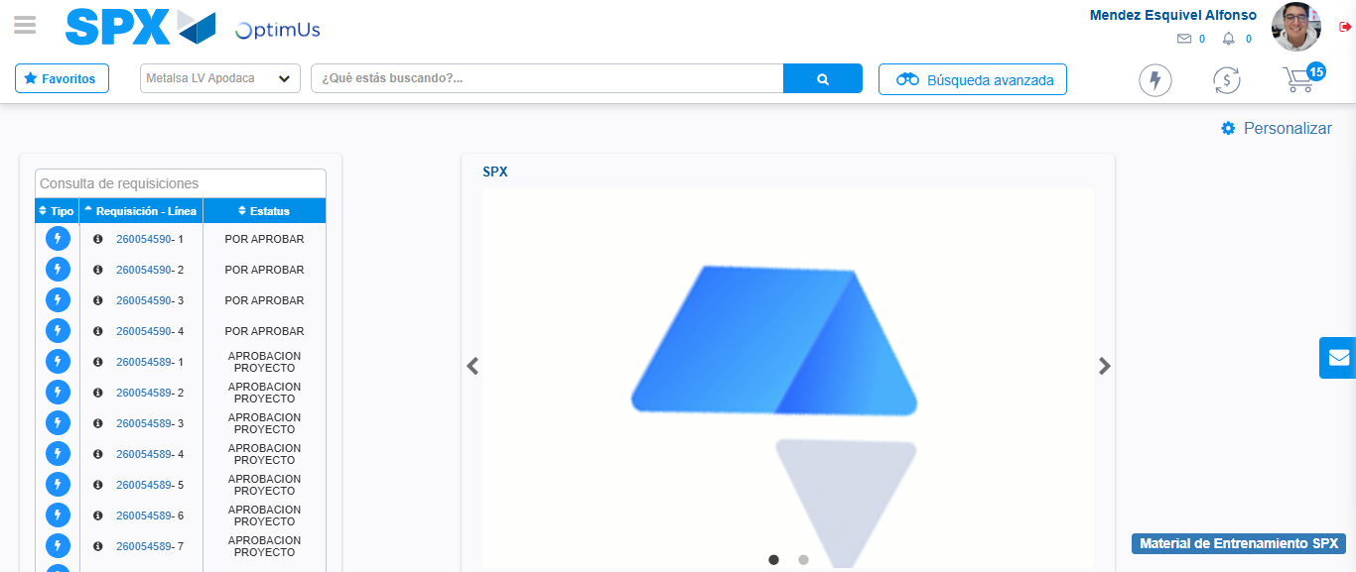Image file-name: QC_Testing-tc006_SPX_Dev5_Crear_Requisicion_Spot_Tipo_Cobro_Proyect_Urgent-1783376870356

Step 8 - Log Out : Log Out SPX
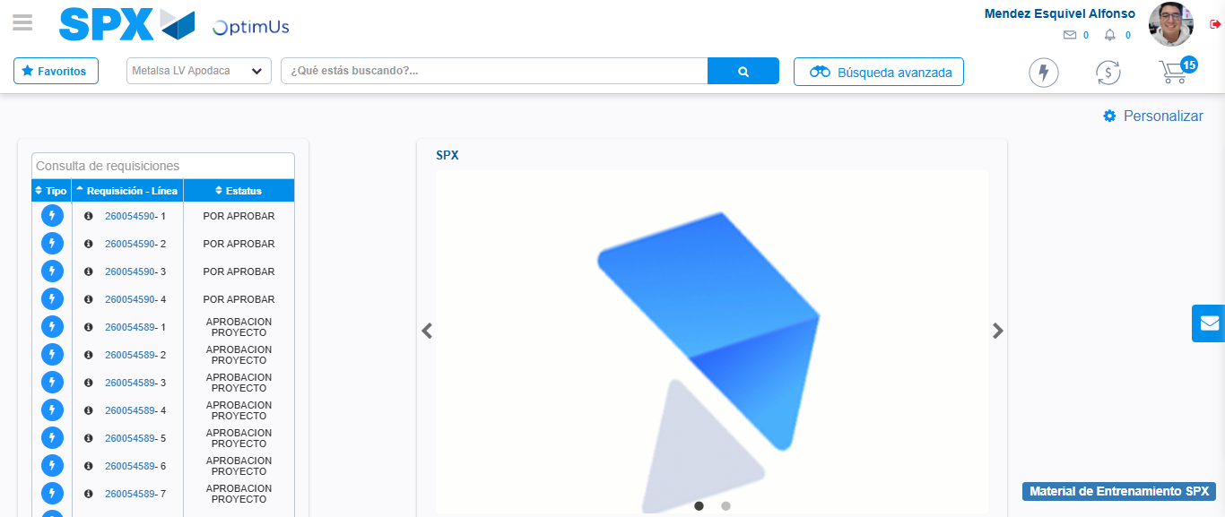Image file-name: QC_Testing-tc006_SPX_Dev5_Crear_Requisicion_Spot_Tipo_Cobro_Proyect_Urgent-1783376870575

